**MOVIE TICKETING BOT**

*A Project Report*

Submitted to Smart Bridge

By

Praveen Joshi Jujjuvarapu -18481A0231

Deepak Teja Kancharla -18481A0235

Sundar Kumar Katikala -18481A0236

Sahith Kavuluri -18481A0237

Ajay Babu Kodali -18481A0238



Under the guidance of

Mr Rammohan Bethi

Lead – Artiﬁcial Intelligence at Smart Bridge Educational Services Pvt. Ltd

**Table of Contents:**

|  |  |  |
| --- | --- | --- |
| **S.No** | **TOPIC** | **PAGE No** |
| 1 | Abstract | 3 |
| 2 | Introduction | 4 |
| 3 | Literature Survey | 5-6 |
| 4 | Theoritical Analysis | 6-8 |
| 5 | Nodal Diagram | 9-11 |
| 6 | Result | 12 |
| 7 | Advanatages | 13 |
| 8 | Applications | 13 |
| 9 | Future Scope | 13 |
| 10 | Conclusion | 14 |
| 11 | Reference | 15 |
|  |  |  |

**Abstract:**

The modern era of technology has a tremendous impact on the society. With the creation of the ultimate virtual assistants, chatbots have become a popular entity in the conversational services. Chatbots are software programs that use natural language understanding and processing. Chatbots are not just restricted to help the user to complete his tasks such as booking a movie ticket or finding the nearest restaurant, but they also provide a source of entertainment, play a major role in home automation projects, give business strategy tips and help in other ways. In this paper, we will provide an insight into what a chatbot is and the types of chatbots. We also propose a classification based on the current market trends, ease of usability and requirements.

**INTRODUCTION:**

Technology plays a massive role in the industry and daily chores. It serves a variety of purposes and is applied in a different way in different parts of the world. Recently, the public has been fantasized by Artificial Intelligence. Artificial Intelligence simulates the cognitive abilities of a human. To be more precise and closely related to humans, the AI Chatbots are now replacing human responses with this software. A Chatbot is a computerized program that acts like a colloquist between the human and the bot, a virtual assistant that has become exceptionally popular in recent years mainly due to dramatic improvements in the areas like artificial intelligence, machine learning and other underlying technologies such as neural networks and natural language processing. These chatbots effectively communicate with any human being using interactive queries. Recently, there’s been a massive increase in many cloud-based chatting bot services which have been made available for the development and improvement of the chatbot sector[1] such as IBM Watson, Clever bot, ELIZA chatbot and many others. These conversational agents have become more responsive and the art of conversation between humans and robots over the past few years have improved drastically. In this paper, we have generalized the AI chatbots and described the general template for the same.

**LITERATURE REVIEW:**

**Definition of a chatbot:**

A chatbot is a conversational software system that is designed to emulate communication capabilities of a human being that interacts automatically with a user. It represents a new, modern form of customer assistance powered by artificial intelligence via a chat interface.

Chatbots are based on AI techniques that understand natural language, identify meaning, emotion, and design for meaningful responses. For example, it makes it easy for customers to get responses to their queries in a convenient way without spending their time waiting in phone queues or send repeated emails. Chatbots can reduce the number of customer calls, average handling time and cost of customer care. However, it is not easy to achieve these functionalities as it requires various complex interactions between systems. Note that the word ‘AI chatbot application system’ or ‘AI chatbot’ is used in this study as a synonym for a conversational agent or advanced dialogue system.

**Taxonomy of Chatbot:**

The recent interest in chatbots can be attributed to two key developments . Firstly, messaging service growth has spread rapidly over the past few years. It incorporates features such as payments, ordering and booking, which would require a separate application or website. So rather than downloading a series of separate applications, users can perform tasks such as buy goods, book restaurant and ask questions all through their favourite messaging apps. Example of some of the popular apps are Facebook Messenger, WhatsApp, WeChat and Line. Secondly, advanced AI techniques in combination with machine learning and deep learning techniques have made considerable progress to improve the quality of understanding and decision making on cheap processing power. It can handle the vast amount of data and process it to get results that exceed human performance.

Chatbot applications can be grouped into four different categories, namely service, commercial, entertainment and advisory chatbot [7]. Service chatbots are designed to provide facilities to customers. For example, logistics firm to respond to questions about deliveries and provide copies of dispatch documents through instant messaging channel rather than emails or phone calls. Commercial chatbots are designed to streamline purchases for customers. For example, a pizza company can take delivery orders or notify promotions via messaging interface. Entertainment chatbots are designed to keep customers engaged with sports, favourite band, movies or other events. It offers the option of placing bets, detail on upcoming events and ticket deals. Advisory chatbots are designed to provide suggestions, give recommendations on service, offer maintenance or repair goods. This type of chatbot can contact people, offer support and advice tips when it is needed.

**IBM Watson:**

Watson is rule-based AI chatbot developed by IBM's Deep QA project . It is designed for information retrieval and question-answering system that incorporates natural language processing and hierarchical machine-learning method. Watson uses a broad range of mechanisms to identify and assign feature values such as names, dates, geographic locations or other entities to generated response. The machine learning system then learns how to combine the values of these features into a final score for each response. Based on that score, it ranks all possible answers and selects one as its top answer. Watson incorporates a variety of technologies including Hadoop, Apache Unstructured Information Management Architecture (UIMA) framework to examines the phrase structure and the grammar of the question to better gauge what's being asked.

Applications for the Watson's underlying cognitive computing technology are almost endless. Because it can process text mining and complex analytics on huge volumes of unstructured data and handle enormous quantities of data. As the application gains experience with more input, it can find enough patterns to make accurate predictions. Besides the advantages of Watson, it has some major drawback such as it does not process structure data directly, no relational databases, higher maintenance cost, targeting towards bigger organizations and take longer time and effort to teach Watson in order to use its full potential.

### **Software:**

Watson uses IBM's DeepQA software and the Apache [UIMA](https://en.wikipedia.org/wiki/UIMA) (Unstructured Information Management Architecture) framework implementation. The system was written in various languages, including [Java](https://en.wikipedia.org/wiki/Java_(programming_language)), [C++](https://en.wikipedia.org/wiki/C%2B%2B), and [Prolog](https://en.wikipedia.org/wiki/Prolog" \o "Prolog), and runs on the [SUSE Linux Enterprise Server](https://en.wikipedia.org/wiki/SUSE_Linux_Enterprise_Server) 11 operating system using the Apache [Hadoop](https://en.wikipedia.org/wiki/Hadoop) framework to provide distributed computing.

### **Hardware:**

The system is workload-optimized, integrating [massively parallel](https://en.wikipedia.org/wiki/Massively_parallel) [POWER7](https://en.wikipedia.org/wiki/POWER7) processors and built on IBM's *DeepQA* technology, which it uses to generate hypotheses, gather massive evidence, and analyze data. Watson employs a cluster of ninety IBM Power 750 servers, each of which uses a 3.5 GHz POWER7 eight-core processor, with four threads per core. In total, the system has 2,880 POWER7 processor threads and 16 [terabytes](https://en.wikipedia.org/wiki/Terabyte) of RAM.

According to [John Rennie](https://en.wikipedia.org/wiki/John_Rennie_(editor)), Watson can process 500 gigabytes, the equivalent of a million books, per second. IBM's [master inventor](https://en.wikipedia.org/wiki/IBM_Master_Inventor) and senior consultant, Tony Pearson, estimated Watson's hardware cost at about three million dollars. Its [Linpack](https://en.wikipedia.org/wiki/Linpack" \o "Linpack) performance stands at 80 TeraFLOPs, which is about half as fast as the cut-off line for the [Top 500 Supercomputers](https://en.wikipedia.org/wiki/Top_500_Supercomputers) list. According to Rennie, all content was stored in Watson's RAM for the Jeopardy game because data stored on [hard drives](https://en.wikipedia.org/wiki/Hard_drive) would be too slow to be competitive with human Jeopardy champions.

## **Operation:**

Watson parses questions into different keywords and sentence fragments in order to find statistically related phrases. Watson's main innovation was not in the creation of a new [algorithm](https://en.wikipedia.org/wiki/Algorithm) for this operation but rather its ability to quickly execute hundreds of proven [language analysis](https://en.wikipedia.org/wiki/Computational_semantics) algorithms simultaneously. The more algorithms that find the same answer independently, the more likely Watson is to be correct. Once Watson has a small number of potential solutions, it is able to check against its database to ascertain whether the solution makes sense or not.

**Nodal diagram:**

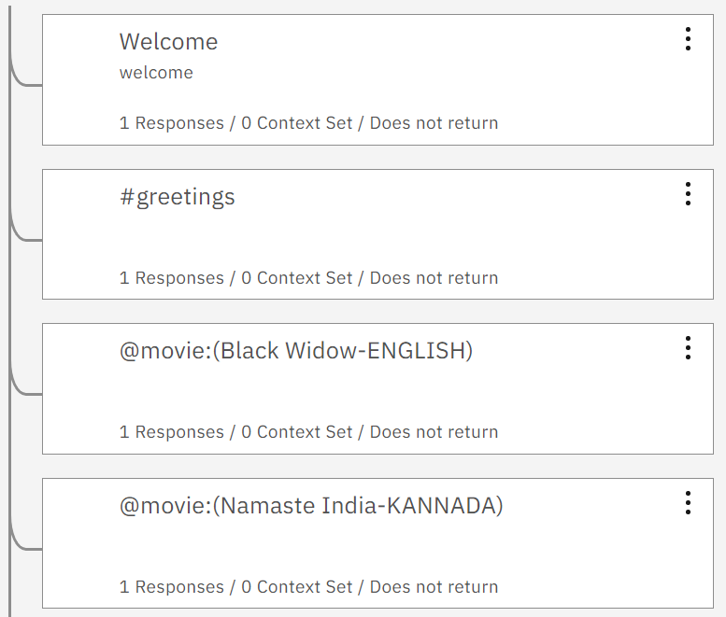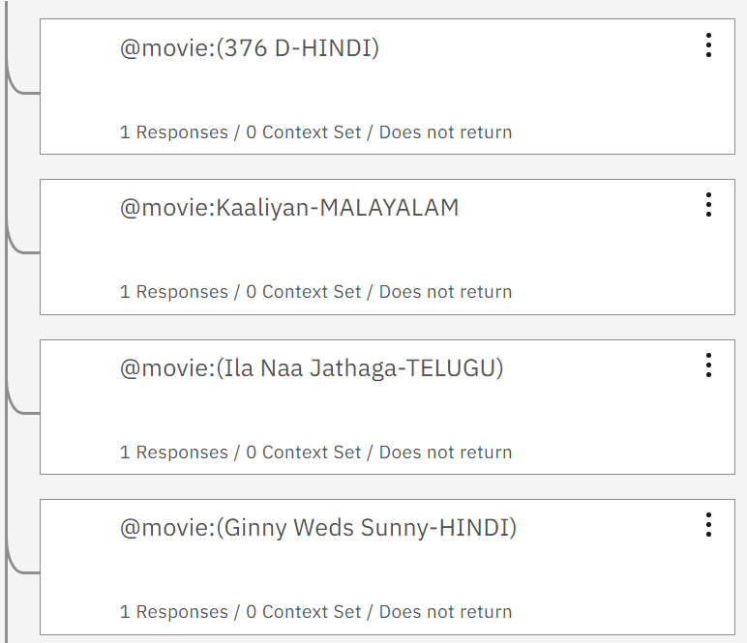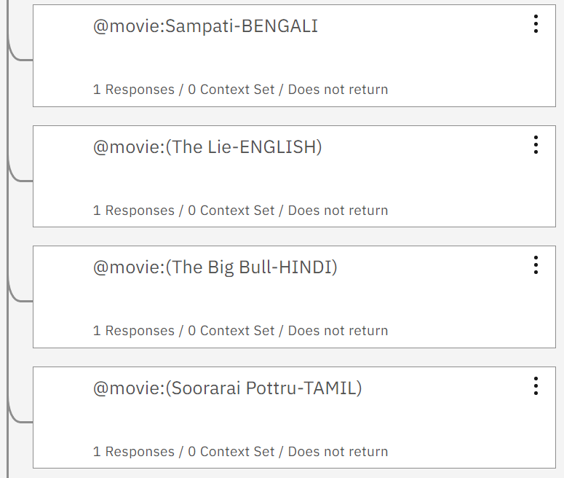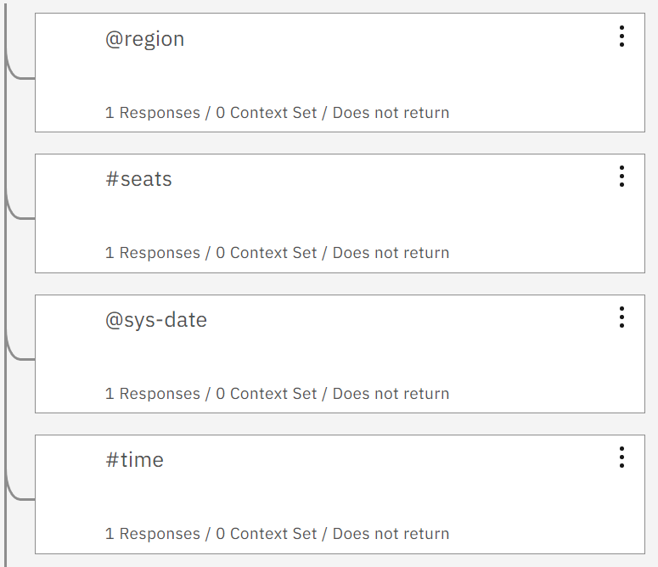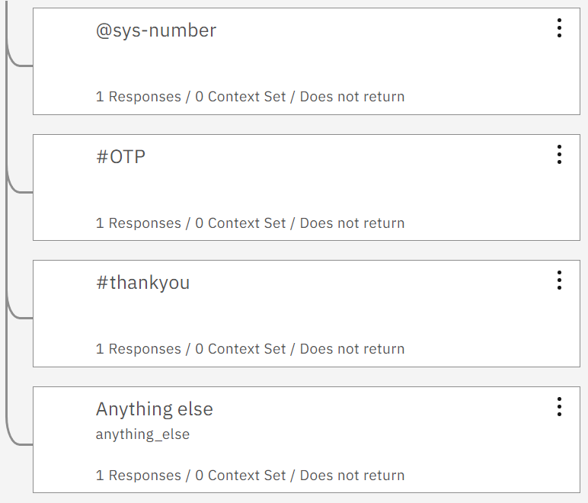

**Results:**

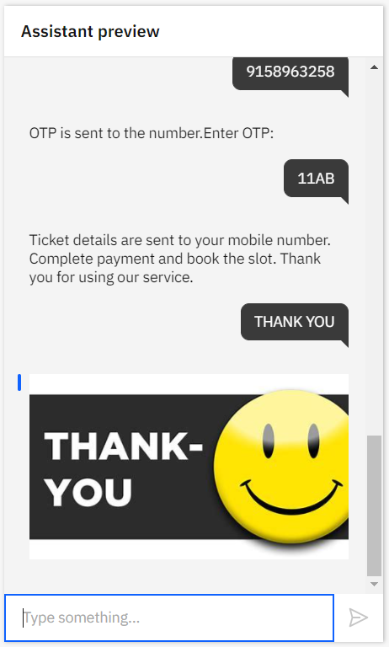

**ADVANATGES:**

* Tickets can be booked online easily.
* This is reliable and provide availability of seats in the theatre without wasting the time
* The events can be scheduled for a later time depending upon your choice.
* The option for auto-checkout is also available for hassle-free purchase for the user.

**APPLICATIONS:**

* This bot can be used to book movie tickets.
* This can also be used to book tickets of any events or shows.

**FUTURE SCOPE:**

By developing this bot ,we can also make it use for various purposes like booking seats in cricket stadium,booking seats for an event.

And it can also be deployed in many areas like online helping bot,online recommendation bot ,online chatbot.**CONCLUSION:**

Thus we can conclude that this movie ticketing bot provide effective solutions for easily availability of  **movie tickets**. Provide simpler way to choose our seat and area **for movie** show To minimize the number of staff at the **ticket** box. To promote **movies** online also this is very helpful.

**Reference:**

https://smartinternz.com/guided-project/movie-ticketing-bot